Lab # 3
JAVA OPERATORS

OBJECTive
To Study Bitwise Logical, Bitwise Operator Assignments, Left and Right Shift, relational and Boolean Logical Operators.

THEORY

The Bitwise Operators

Java defines several bitwise operators which can be applied to the integer types, long,
int, short, char, and byte. These operators act upon the individual bits of their operands.
They are summarized in the following table:

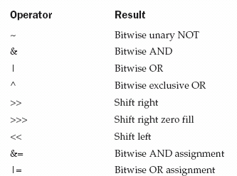

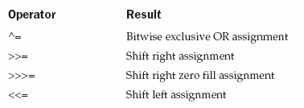

The Bitwise Logical Operators

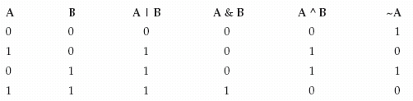
The bitwise logical operators are &, |, ^, and ~. The following table shows the outcome of each operation. In the discussion that follows, keep in mind that the bitwise operators are applied to each individual bit within each operand.

The following program demonstrates the bitwise logical operators:

// Demonstrate the bitwise logical operators.
public class Bitwise{
public static void main (String[] args){
int a=10;
int b=28;
System.out.println(a&b);
System.out.println(a|b);
System.out.println(a^b);
}
}

The Left Shift

// Left shifting a byte value.
public class ByteShift {
public static void main(String args[]) {
byte a = 64, b;
int i;
i = a << 2;
b = (byte) (a << 2);
System.out.println("Original value of a: " + a);
System.out.println("i and b: " + i + " " + b);
}
}

Output
Original value of a: 64
i and b: 256 0

The Unsigned Right Shift

As you have just seen, the >> operator automatically fills the high-order bit with its
previous contents each time a shift occurs. This preserves the sign of the value.

// Unsigned shifting a byte value.
public class ByteUShift {
public static void main(String args[]) {
char hex[] = {'0', '1', '2', '3', '4', '5', '6', '7',
'8', '9', 'a', 'b', 'c', 'd', 'e', 'f'};
byte b = (byte) 0xf1;
byte c = (byte) (b >> 4);
byte d = (byte) (b >>> 4);
byte e = (byte) ((b & 0xff) >> 4);
System.out.println(" b = 0x"+ hex[(b >> 4) & 0x0f] + hex[b & 0x0f]);
System.out.println(" b >> 4 = 0x"+ hex[(c >> 4) & 0x0f] + hex[c & 0x0f]);
System.out.println(" b >>> 4 = 0x"+ hex[(d >> 4) & 0x0f] + hex[d & 0x0f]);
System.out.println("(b & 0xff) >> 4 = 0x"+ hex[(e >> 4) & 0x0f] + hex[e & 0x0f]);
}
}

Output
b = 0xf1
b >> 4 = 0xff
b >>> 4 = 0xff
(b & 0xff) >> 4 = 0x0f

Bitwise Operator Assignments
public class OpBitEquals {
public static void main(String args[]) {
int a = 1;
int b = 2;
int c = 3;
a |= 4;
b >>= 1;
c <<= 1;
a ^= c;
System.out.println("a = " + a);
System.out.println("b = " + b);
System.out.println("c = " + c);
}
}
Output
a = 3
b = 1
c = 6

Relational Operators

The relational operators determine the relationship that one operand has to the other.
Specifically, they determine equality and ordering. The relational operators are
shown here:

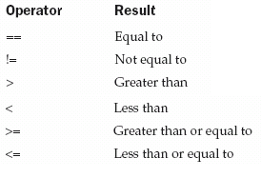

class ComparisonDemo {

public static void main(String[] args){
int value1 = 1;
int value2 = 2;
if(value1 == value2)
System.out.println("value1 == value2");
if(value1 != value2)
System.out.println("value1 != value2");
if(value1 > value2)
System.out.println("value1 > value2");
if(value1 < value2)
System.out.println("value1 < value2");
if(value1 <= value2)
System.out.println("value1 <= value2");
}
}

Output:
value1 != value2
value1 < value2
value1 <= value2

Boolean Logical Operators
The Boolean logical operators shown here operate only on boolean operands. All of the binary logical operators combine two boolean values to form a resultant boolean value.
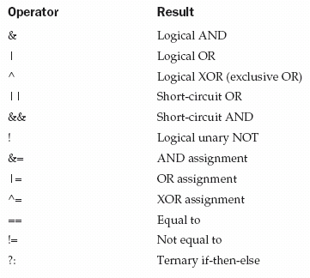

An Example
The following table lists some of the converters and flags that are used in the sample program, TestFormat.java, that follows the table.
Converters and Flags Used in TestFormat.java
Converter | Flag | Explanation
d |  | A decimal integer.
f |  | A float.
n |  | A new line character appropriate to the platform running the application. You should always use %n, rather than \n.
tB |  | A date & time conversion—locale-specific full name of month.
td, te |  | A date & time conversion—2-digit day of month. td has leading zeroes as needed, te does not.
ty, tY |  | A date & time conversion—ty = 2-digit year, tY = 4-digit year.
tl |  | A date & time conversion—hour in 12-hour clock.
tM |  | A date & time conversion—minutes in 2 digits, with leading zeroes as necessary.
tp |  | A date & time conversion—locale-specific am/pm (lower case).
tm |  | A date & time conversion—months in 2 digits, with leading zeroes as necessary.
tD |  | A date & time conversion—date as %tm%td%ty
 | 08 | Eight characters in width, with leading zeroes as necessary.
 | + | Includes sign, whether positive or negative.
 | , | Includes locale-specific grouping characters.
 | - | Left-justified..
 | .3 | Three places after decimal point.
 | 10.3 | Ten characters in width, right justified, with three places after decimal point.

The supported conversion types are listed below, along with their meanings, and the corresponding arguments expected in the argument vector:
type character | input | string result
%d | signed int | signed decimal integer
%u | unsigned int | unsigned decimal integer
%o | unsigned int | unsigned octal integer
%x, %X | unsigned int | unsigned hexadecimal integer, lowercase or uppercase
%z[n], %Z[n] | unsigned int | unsigned integer base n, with n coded in decimal; include square brackets
%f | float | real number, standard notation
%e, %E | float | real number, scientific notation (lowercase or uppercase exponent marker)
%g, %G | float | same format as %f or %e, depending on the value. Scientific notation is used only if the exponent is greater than the precision or less than -4.
%s | String | string
%c | char | character
%p | Object | object identity hash code (i.e., pointer value), in unsigned hexadecimal
additional format specifiers that do not result in argument conversions
%\n | (none) | platform-independent line separator (see §3)
%n | (null) | counts characters (see §4)

import java.util.Calendar;
import java.util.Locale;

public class TestFormat {

public static void main(String[] args) {
long n = 461012;
System.out.format("%d%n", n); // --> "461012"
System.out.format("%08d%n", n); // --> "00461012"
System.out.format("%+8d%n", n); // --> " +461012"
System.out.format("%,8d%n", n); // --> " 461,012"
System.out.format("%+,8d%n%n", n); // --> "+461,012"

double pi = Math.PI;

System.out.format("%f%n", pi); // --> "3.141593"
System.out.format("%.3f%n", pi); // --> "3.142"
System.out.format("%10.3f%n", pi); // --> " 3.142"
System.out.format("%-10.3f%n", pi); // --> "3.142"
System.out.format(Locale.FRANCE,
"%-10.4f%n%n", pi); // --> "3,1416"

Calendar c = Calendar.getInstance();
System.out.format("%tB %te, %tY%n", c, c, c); // --> "May 29, 2006"

System.out.format("%tl:%tM %tp%n", c, c, c); // --> "2:34 am"

System.out.format("%tD%n", c); // --> "05/29/06"
}
}

LAB TASK

- Implement following circuit into java programming language.

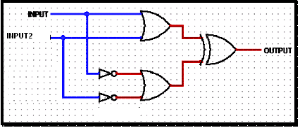

- Write Java program to allow the user to input his/her age. Then the program will show if the person is eligible to vote. A person who is eligible to vote must be older than or equal to 18 years old.
- Write a program that take 1 byte input integer (positive number) and generate its negative value.(Hint: use bitwise operators).
- Create a class containing main method and taking input int, float, string, double, long variables.
- Write a program that takes input of three subjects. Find the average marks & display it.
- Input integer value and display its square root.
- Write a program that print salary sheet of employee by taking input employee name, designation, date of joining, department, basic salary and allowances.
- Take a number as user input and convert this number into octal and binary number.
- Write a program that print the student Biodata by taking all data input from user.
- Write a dice program that generate random number from 1 to 6 and match it with user input, if inputted number match with dice number user win.

- Write a program to perform multiplication of a integer number by 2 and division by 2 without using arithmetic operators and math class.
- Write a program to produce a series 64,16,8,4,2,1 by using shift operator.

